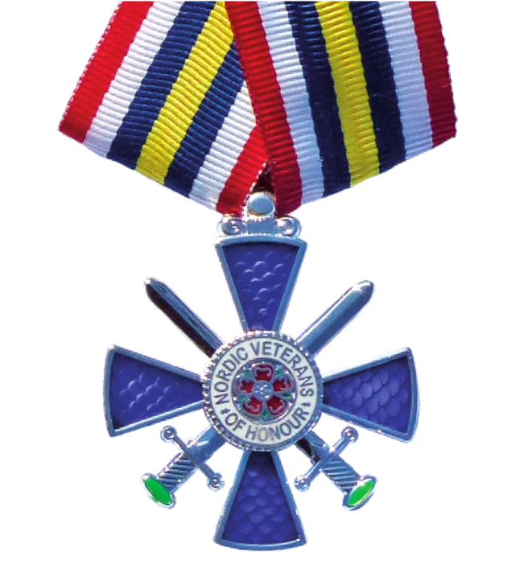
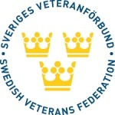
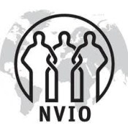
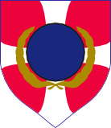
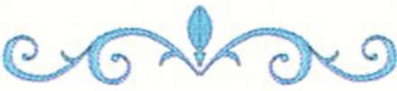
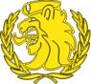

NORDIC VETERANS MEDAL OF HONOUR

Awarded in Silver to

For outstanding contribution to

FRIENDSHIP ACROSS THE FRONTIERS

Board of the Nordic Veterans Federation
Date:

President/Vice President

