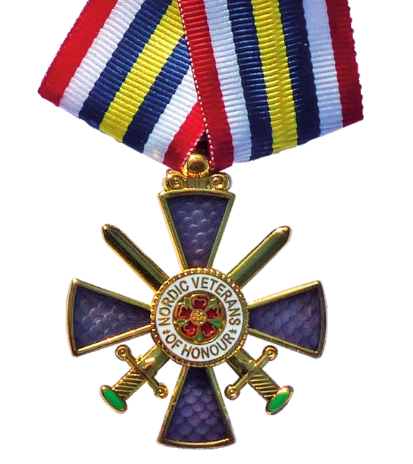
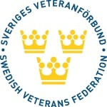
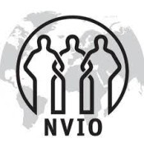
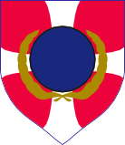
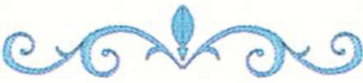
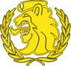

NORDIC VETERANS MEDAL OF HONOUR

Awarded in Gold to

For outstanding contribution to

FRIENDSHIP ACROSS THE FRONTIERS

Board of the Nordic Veterans Federation

Date:

President

